Installations Document

Visual Studio components:

In window search type “Visual Studio Installer” and open it.

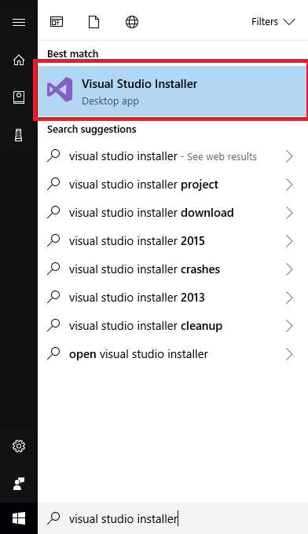

Find visual studio community edition and press the “Modify” button below it.

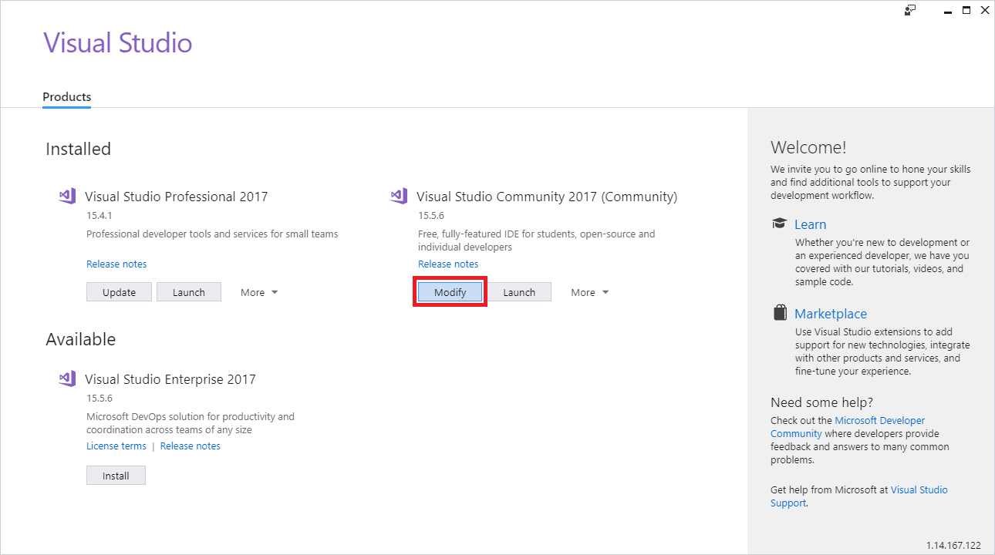

Verify that the asp.net development checkbox is marked

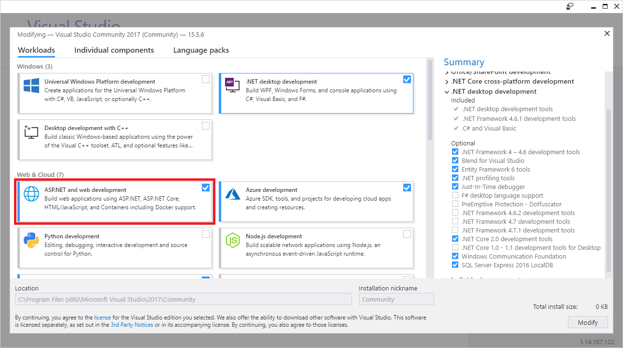

Verify that the .net desktop development checkbox is marked (for WPF designer)

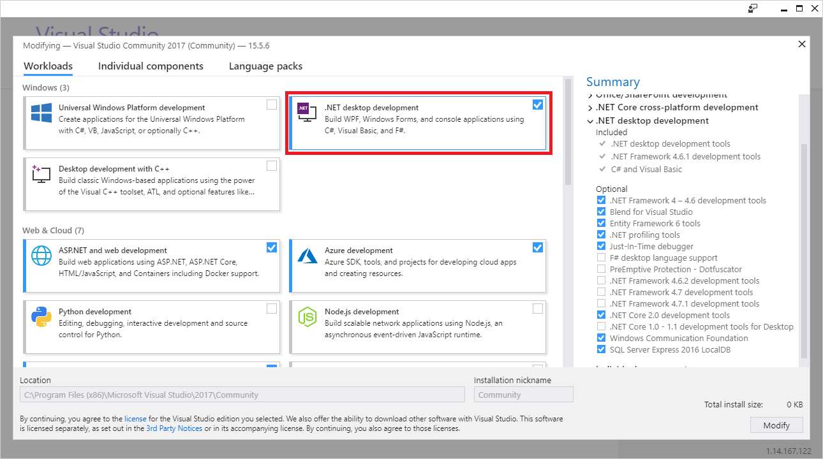

Verify that under individual components tab, the class designer checkbox is marked

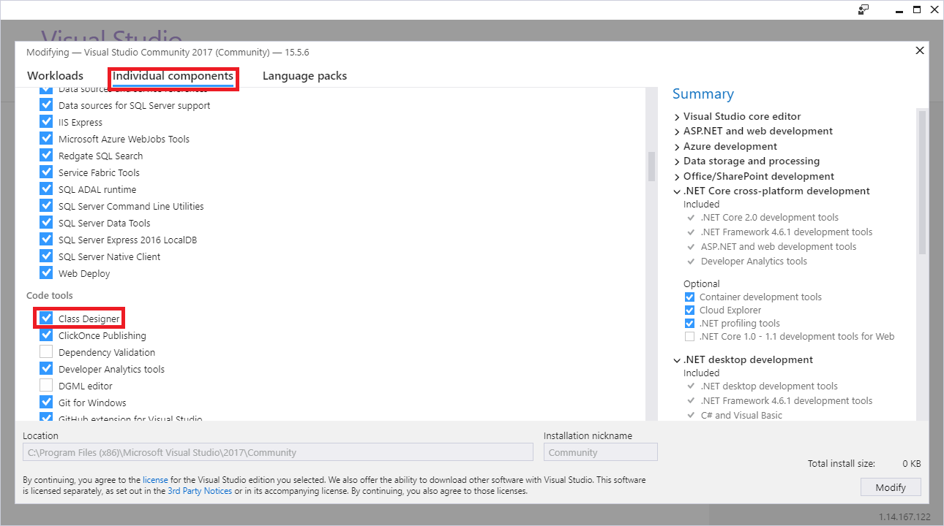

Press “Modify” and continue the installation process.

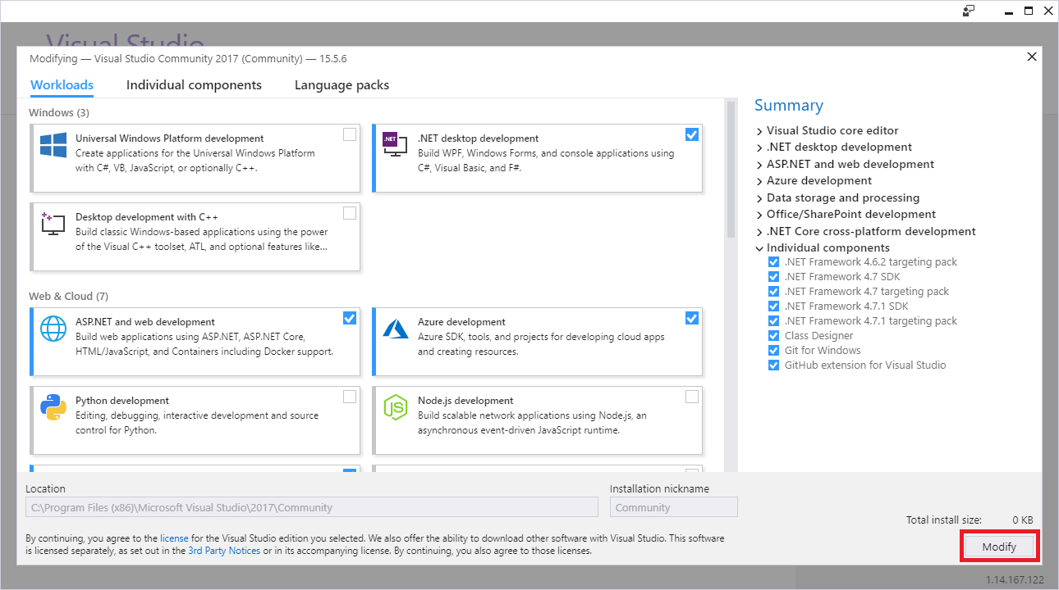

SQL server management

In the Address bar of the Microsoft Edge window, type <https://go.microsoft.com/fwlink/?linkid=867670>

Download the exe file. Once it downloaded open the exe file and click the **install** button on the SQL server management installation window.

When SQL server management installation is complete click **close**.

SQL server management instance

Open **command prompt** window and write the next command:

C:\> SqlLocalDb info

Check if the output of this command includes **MSSQLLocalDB**.

To create this instance in case it is missing write the following command in the **command prompt** window:

SqlLocalDb create “MSSQLLocalDB”